Development Documentation

**1. Introduction 3**

**2. Property Management 3**

a. Setting up 3

i. Categories 3

ii. Amenities 4

iii. Services 5

iv. Attributes 5

v. Bed Types 5

vi. Seasons 6

vii. Rates 7

b. Create a Property 7

**3. Booking Management 10**

a. Setting up 10

i. Booking Rules 10

ii. Taxes and Fees 10

iii. Coupons 11

iv. Booking Settings 12

v. Payment Gateways 12

b. Placing Bookings 13

c. Manage Bookings 14

**4. User Management 16**

**5. Additional Features 16**

a. WP Mail SMTP 16

b. WP Forms 16

c. 16

**6. 16**

# Introduction

# Property Management

Property Management consists of various tasks. In this section, we will set up the necessary elements to add a new property to the website.

## Setting up

### Categories

Navigate to Accommodation/Categories (Figure ). New Categories can be added to give the customer more information about the property. We decided to add location information into the categories but it is not limited to it (Figure ). Categories will be available for selection in the creation of a new property. Categories can be added by administrators as well as property owners.

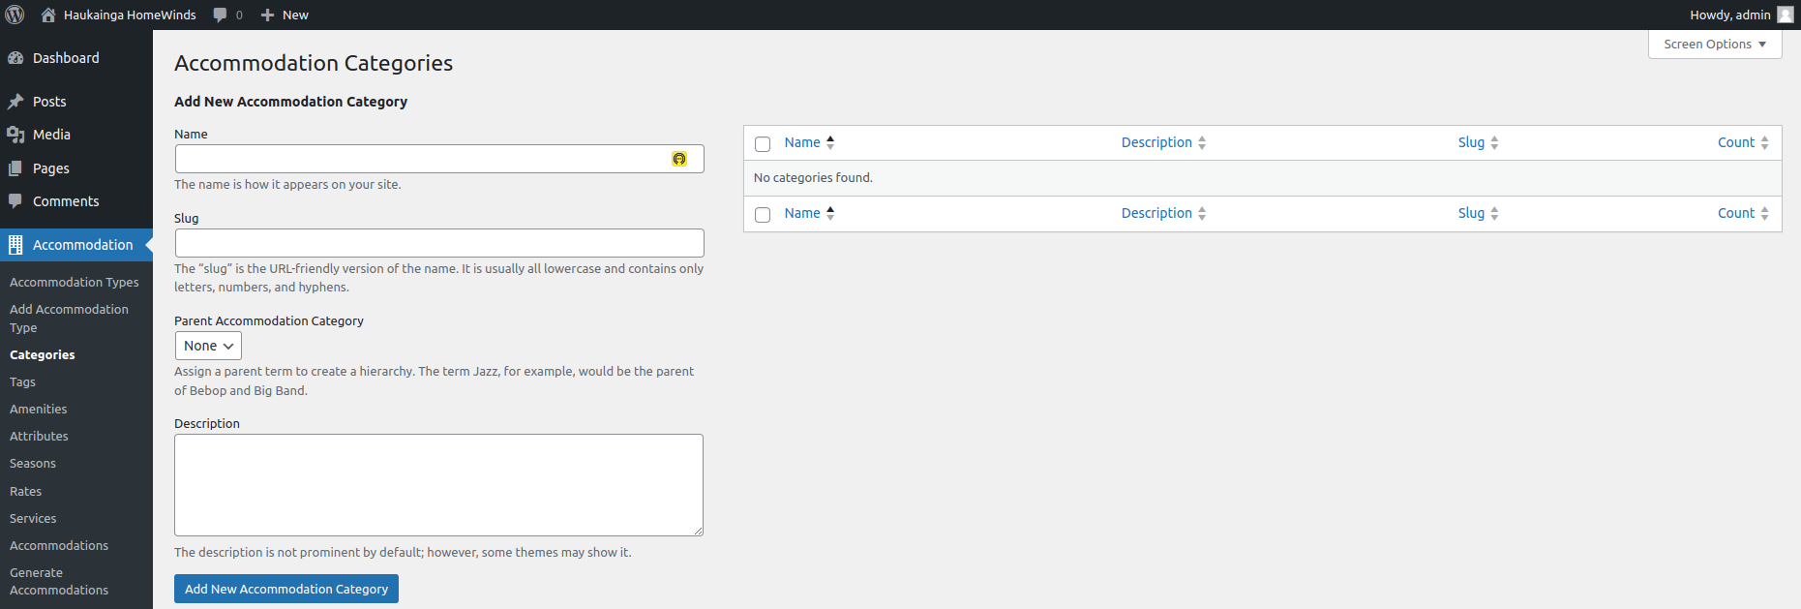

*Figure - Add new Categories*

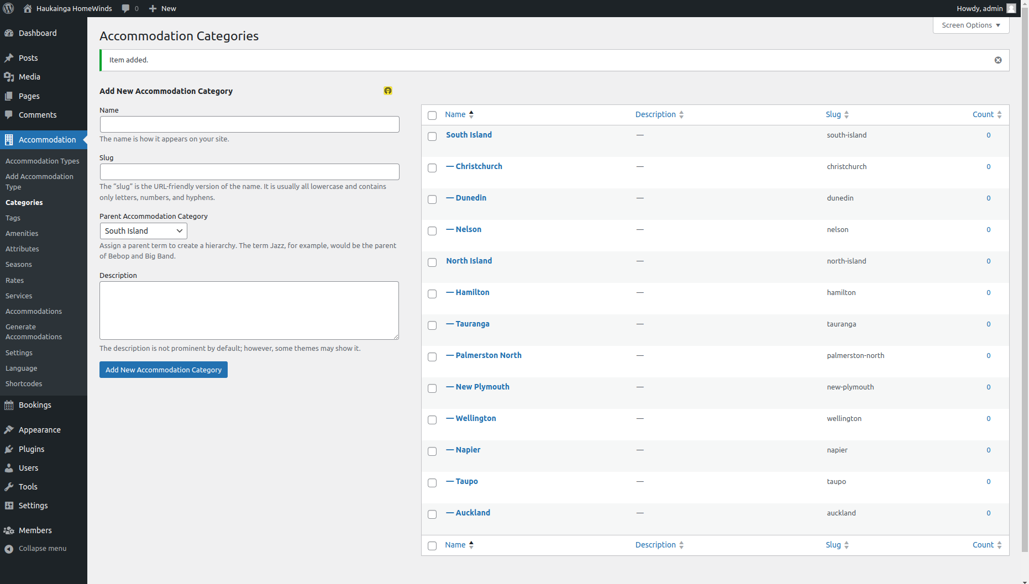

*Figure - Locations added*

### Amenities

Navigate to Accommodation/Amenities (Figure ). In this part, we will add amenities and possible features that can be selected during the creation of a new property. We decided to add information about the rooms as well as general amenities that could be of value to customers (Figure ). Amenities can be added by administrators and property owners.

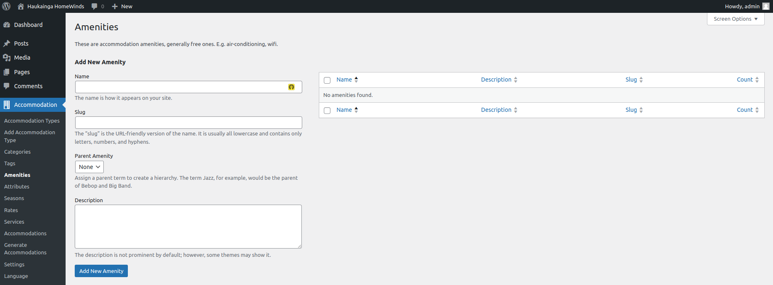

*Figure - Adding Amenities*

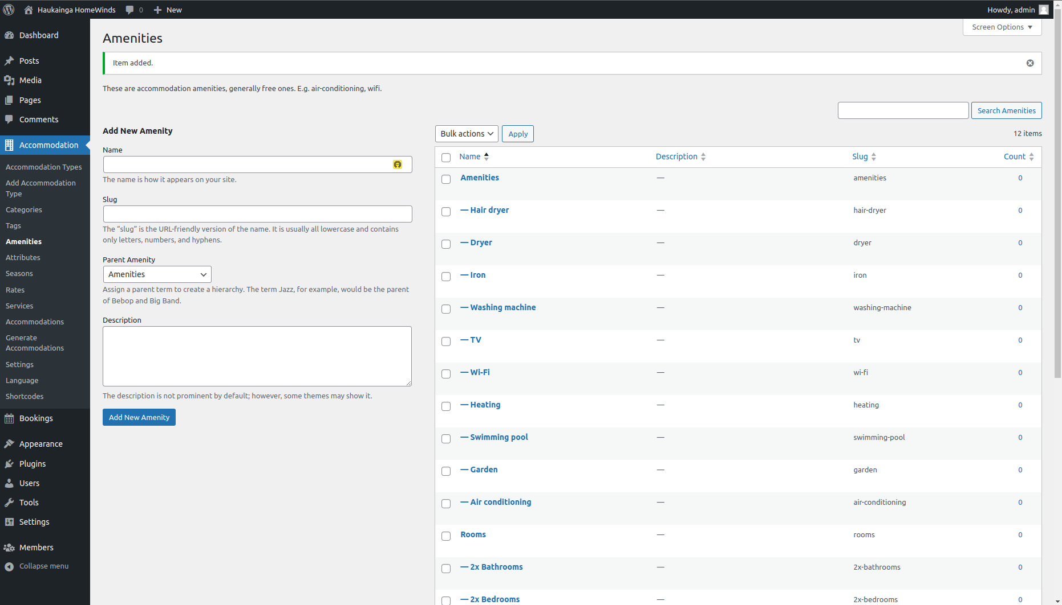

*Figure - Amenities added*

### Services

Navigate to Accommodation/Services (Figure ). The client stated that there might be collaborations with other businesses and service providers in the future. Services allow the property owners to add these third-party features, and adjust pricing and rates. Because this feature is not in use at the current stage, we did not include services during development. Services can be selected during the creation of a property. Services also include a page with additional information that can be customized by using “Elementor” or the WordPress page editor.

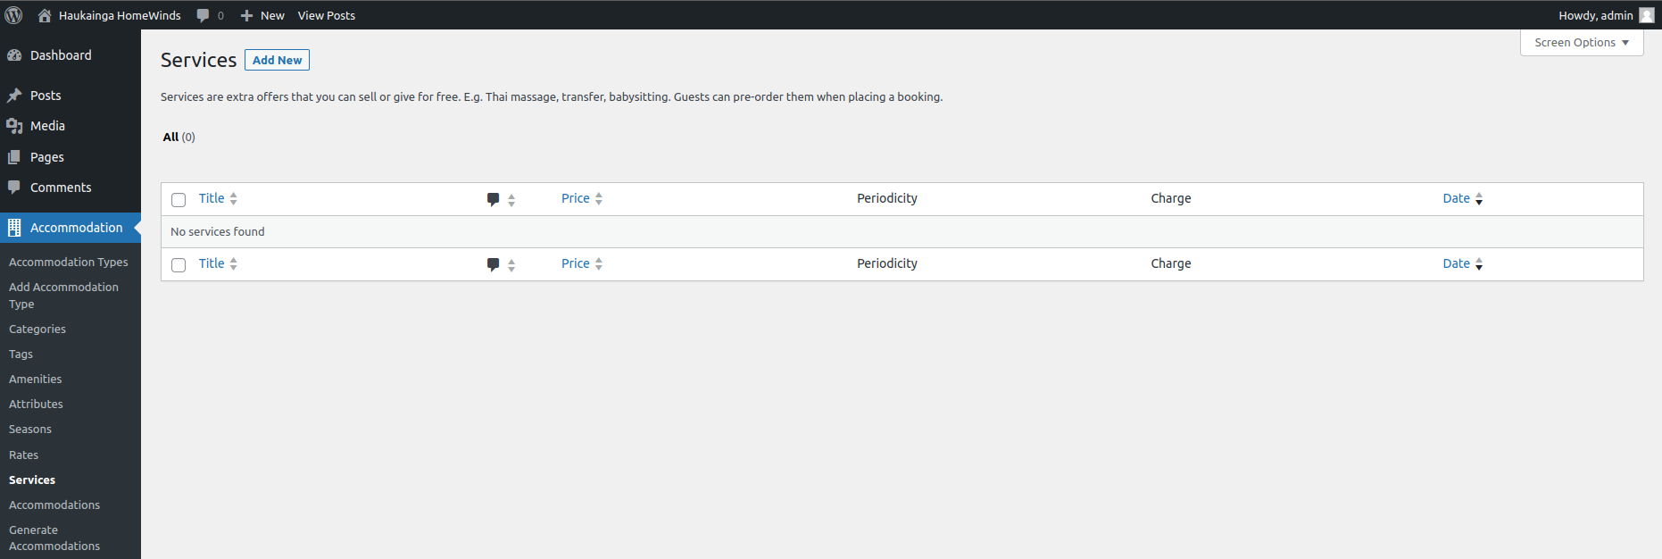

*Figure - Adding Services*

### Attributes

Navigate to Accommodation/Attributes (Figure ). This is a “Pro” feature of the Hotel Booking Plugin. We encourage the client to invest in these features. Attributes allow more detail than categories. Search functionalities also get extended and will be beneficial for the user experience.

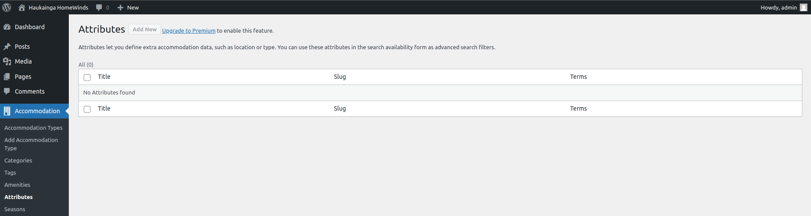

*Figure - Adding new Attributes*

### Bed Types

Navigate to Accommodations/Settings/General => Misc # (Figure ). Here we can add different types of beds that will be available to add to a property.

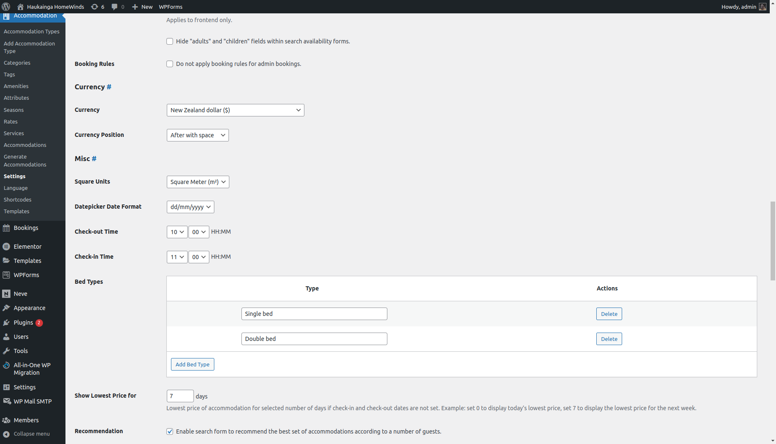

Figure - Adding Bed Types

### Seasons

Navigate to Accommodation/Seasons (Figure ). As stated by the client, the website should include features for seasonal pricing. New seasons can be added by selecting start and end dates as well as applying seasonal prices only for specified days (Figure ). This could also be used to implement special prices for public holidays. Seasons will be available to set the prices for the properties (Figure ).

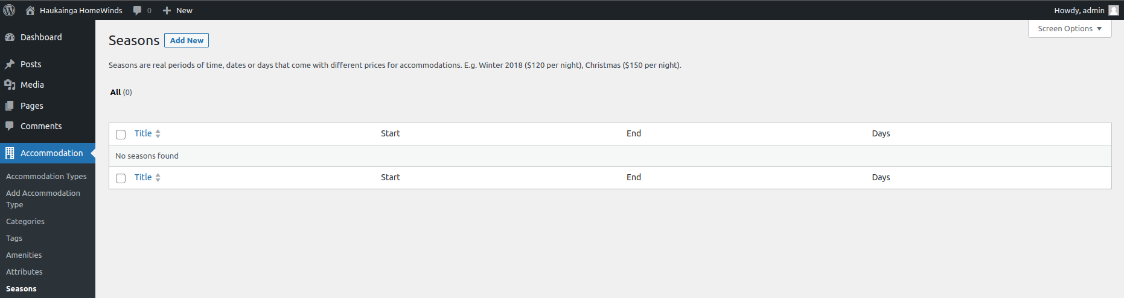

*Figure - Adding New Seasons*

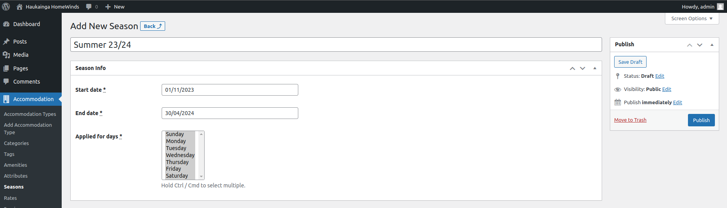

*Figure - Configuring a new Season*

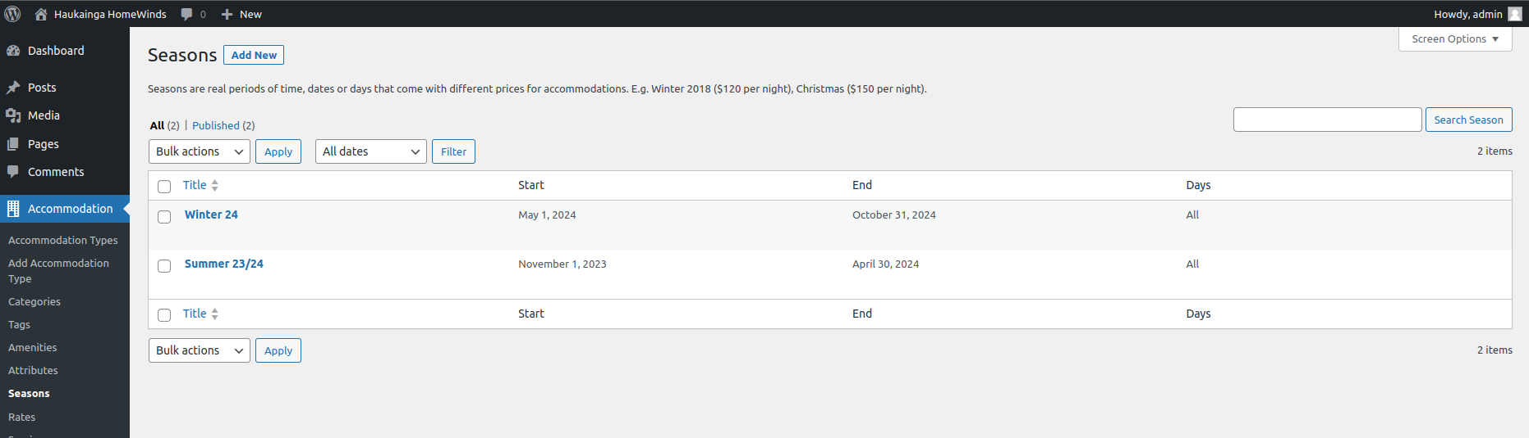

*Figure - Seasons added*

### Rates

Navigate to Accommodation/Rates (Figure ). Rates can be used to add different prices based on the previously created seasons (Figure ). Multiple rates can be added to also include special features or partial renting.

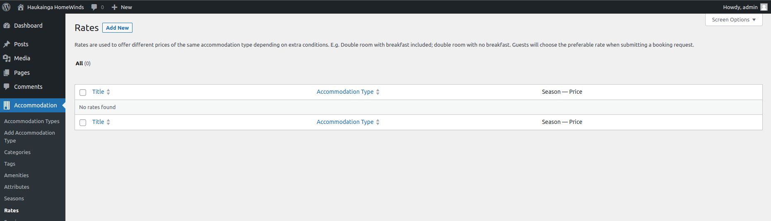

*Figure - Adding Rates*

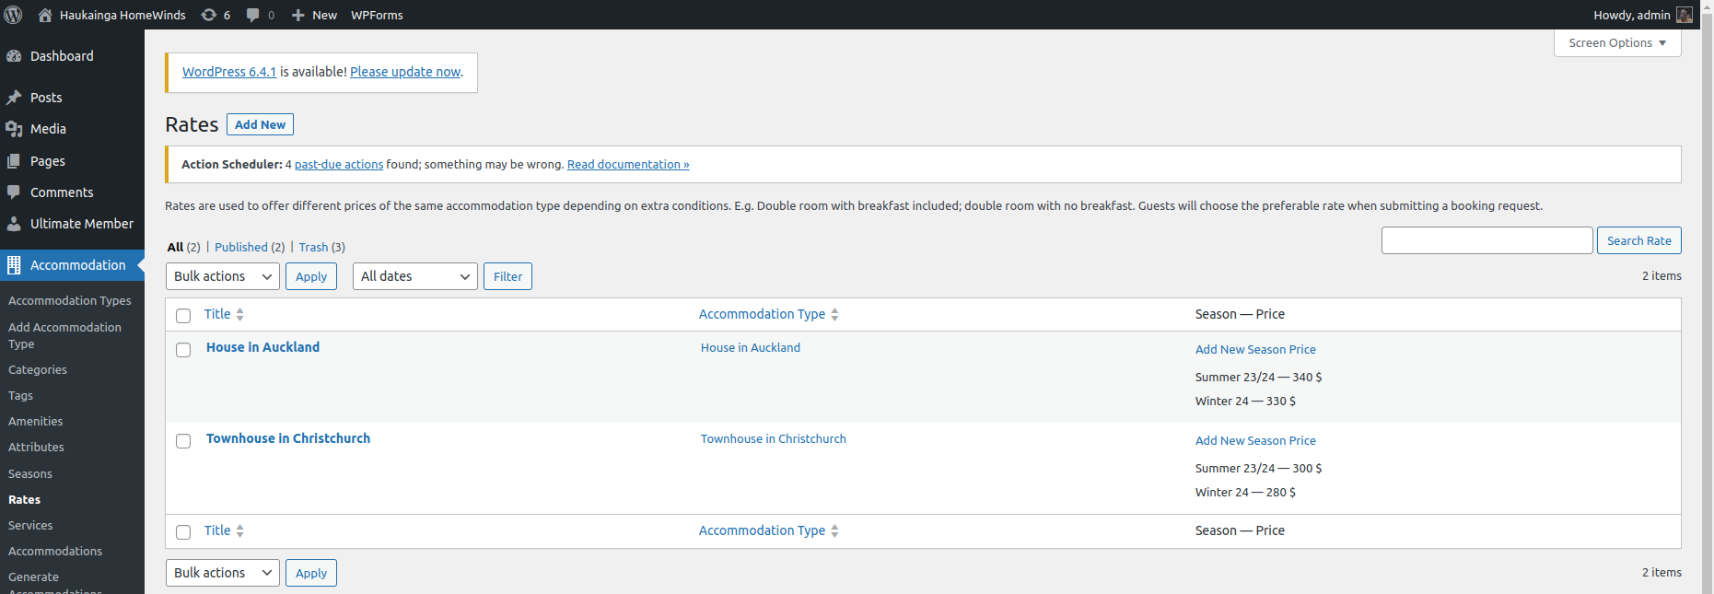

*Figure - Rates added*

## Create a Property

After the setup,￼ we are now able to create a new property entry. Properties can be added, edited, and deleted by administrators or the property owner.

Navigate to Accommodation/Accommodation Types (Figure ).

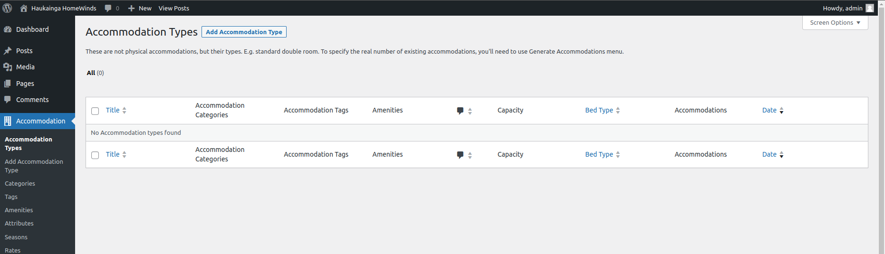

*Figure - Adding a new Property*

The property owner can use the WordPress editor to customize his property and include various “Blocks” to include media, descriptions, and a map showing the location (Figure ).

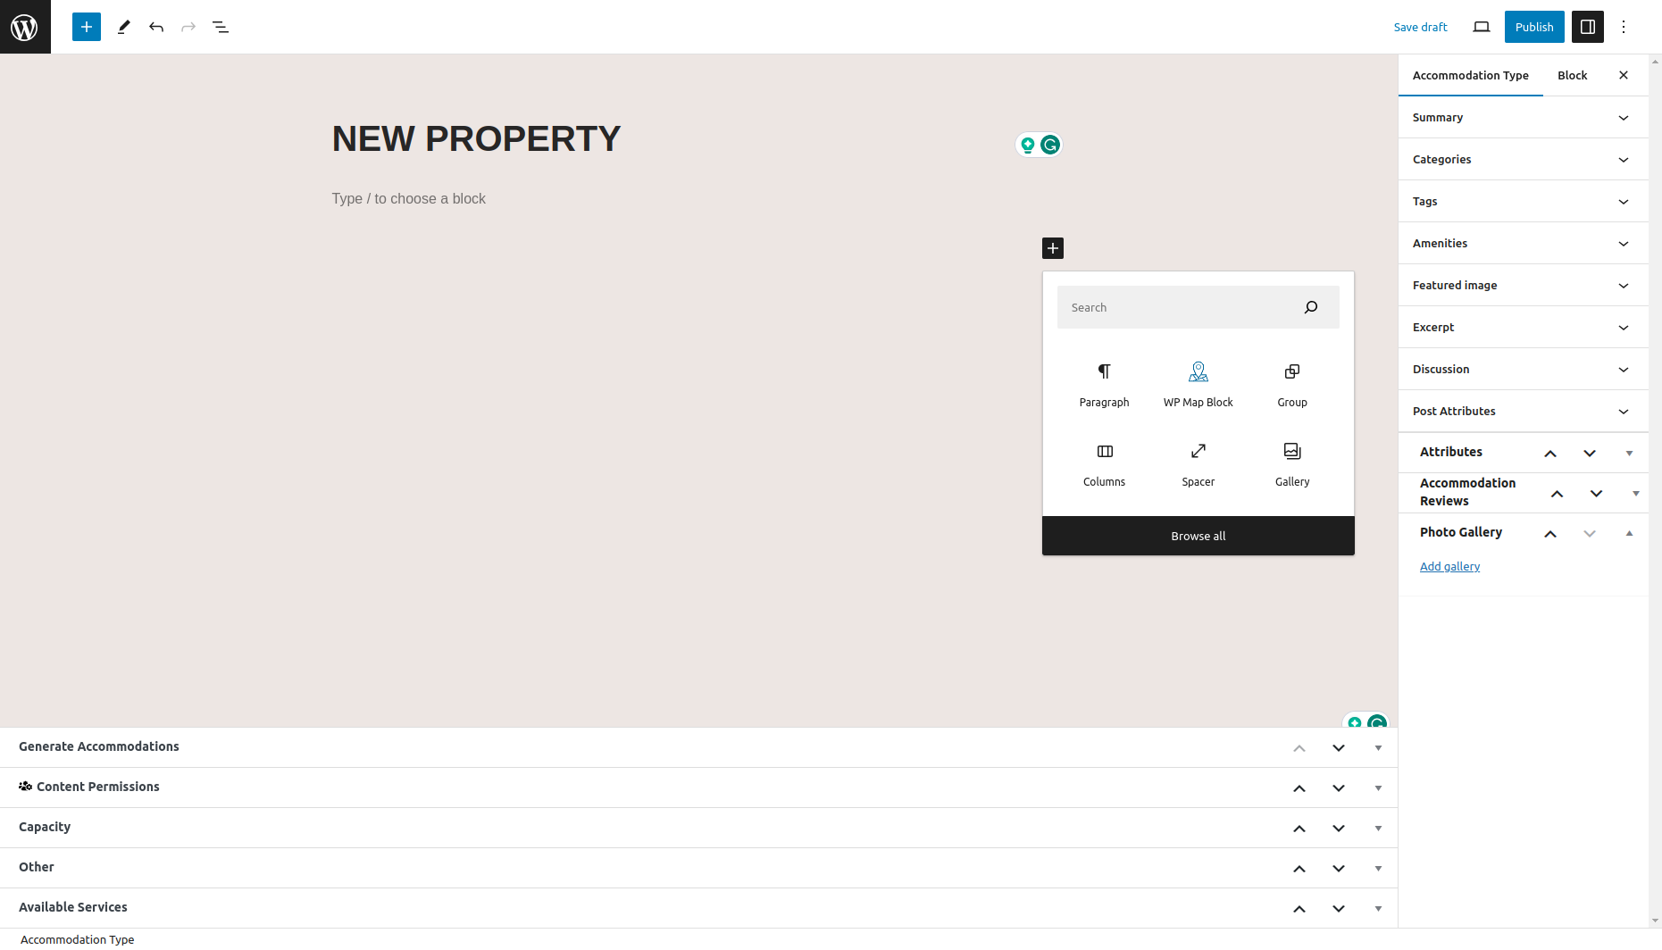

*Figure - Property Editor*

On the menu on the right side of the screen, you can add the previously created Categories, Amenities, and Attributes. A Feature image and excerpt can be added that gets displayed while the user is browsing through the property listings. Comments can be enabled in the Discussion tab. When using the “Pro” version of the Hotel Booking Plugin, the review and rating functionalities can be enabled. A photo gallery can be added to include more images showcasing the property.

The menu on the bottom of the screen allows the property owner to set the capacity of the property, adding “View” tags to give more details about the location. The bed type can be selected. These get added in Accommodation/Settings. Services can be added.

“Generate Accommodations” must be set to 1. A property only exists once, but this functionality can be used for listing rooms or multiple houses with the same specifications.

The client requested a map feature to be available to add to the properties. This can be achieved by adding a WordPress Map Block. Navigating to the Block settings on the right allows the property owner to change the marker location (Figure ). The size and placement of the map can be easily adjusted using the Editor.

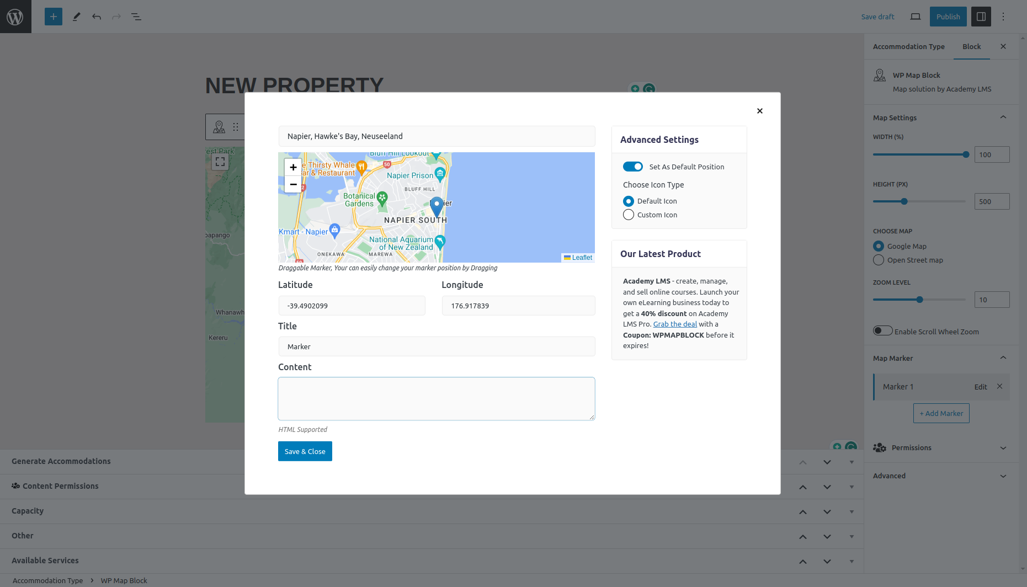

*Figure - Adding a map*

To finish the creation of the property we can publish the site at the top right of the screen. The Property is now available at the site. To make it bookable we will continue with the booking management guide.

# Booking Management

After adding a Property to the website, we can continue managing the bookings.

In this guide, we will look at different settings and options to allow and manage bookings of properties.

## Setting up

### Booking Rules

Navigate to Bookings/Booking Rules (Figure ). Here we can add several rules that get applied for booking the properties. The property owner can edit check-in/out times and minimum/maximum stay times. Blocking, buffering, and rules for booking in advance offer extended management options.

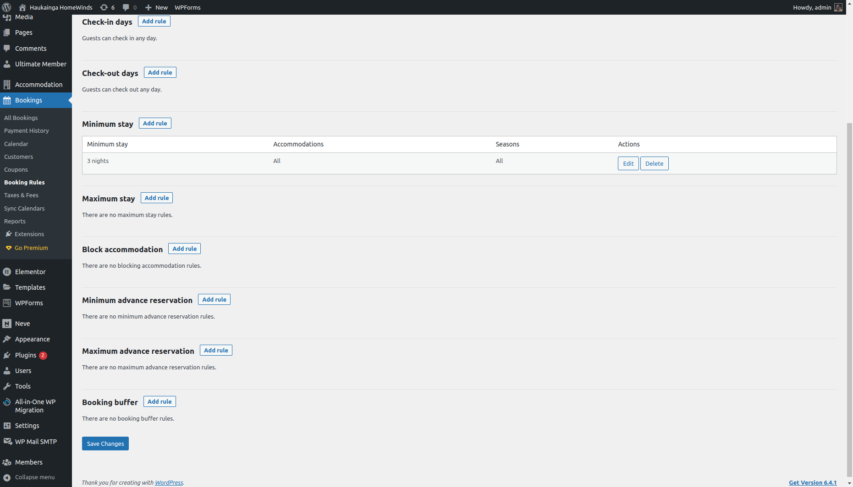

*Figure - Adding Booking Rules*

### Taxes and Fees

Navigate to Bookings/Taxes and Fees (Figure ). There are multiple options to add additional taxes and fees.

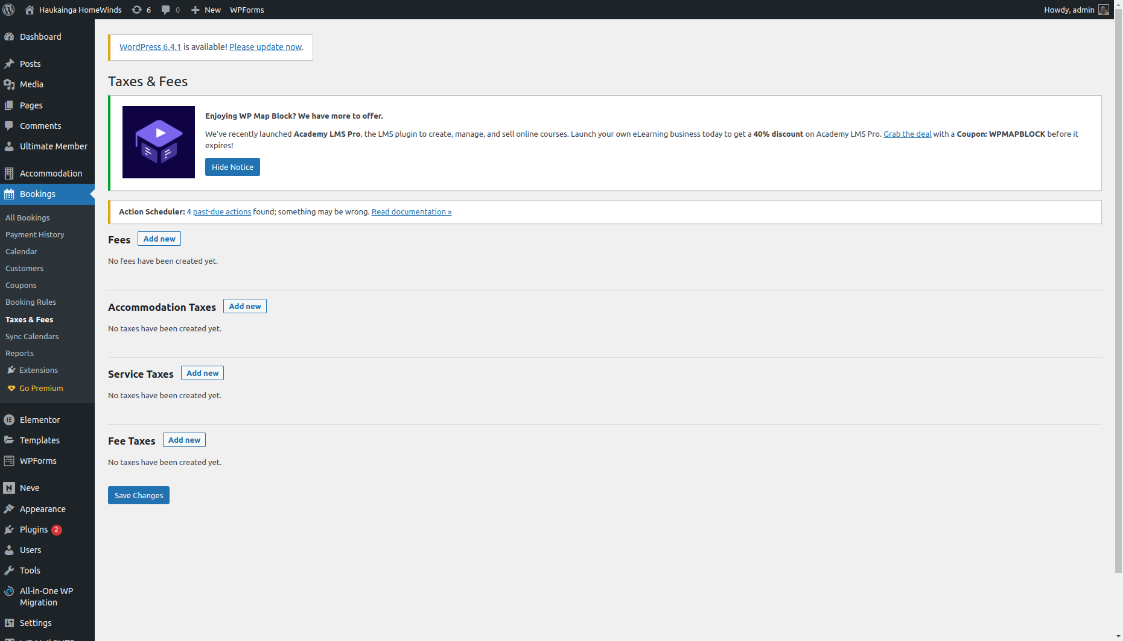

*Figure - Adding Taxes and Fees*

### Coupons

Navigate to Bookings/Coupons (Figure ). Property owners might want to offer special discounts or coupons for advertisement reasons. Coupons can be configured in various ways to match the requirements of the property owner (Figure ).

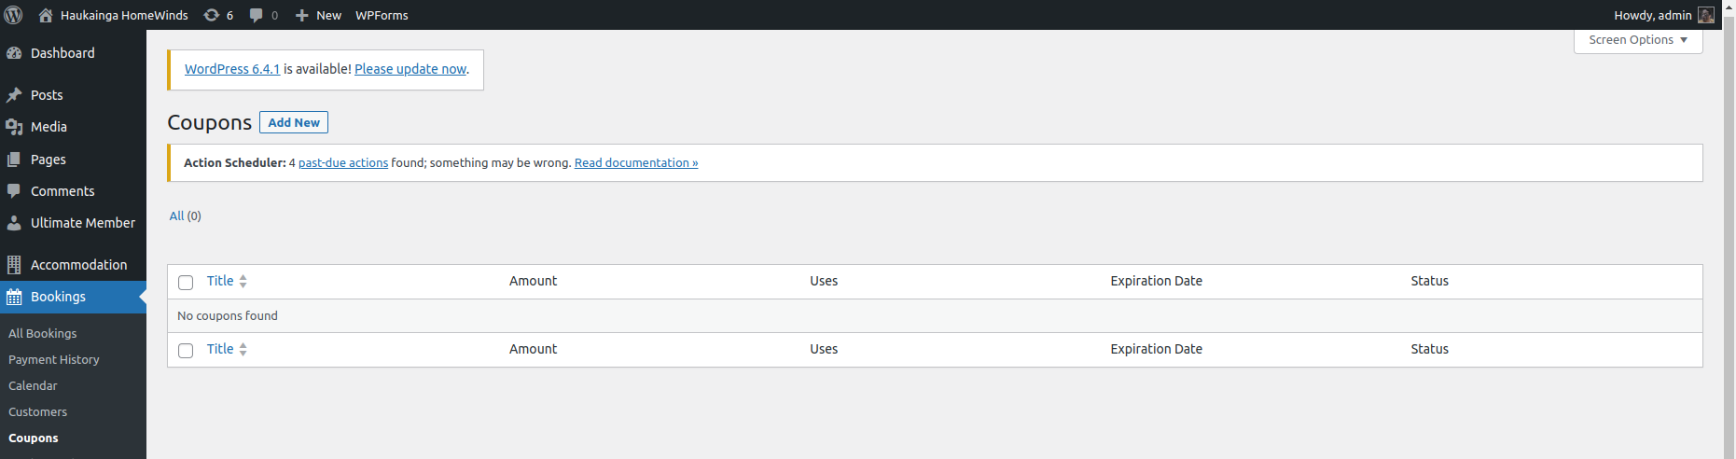

*Figure - Adding Coupons*

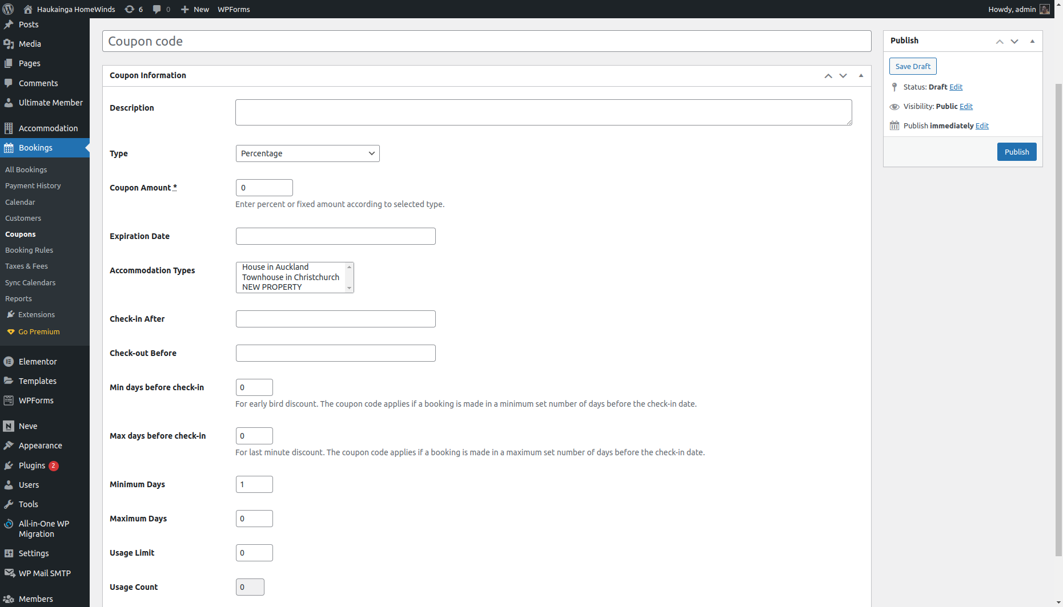

*Figure - Creating a Coupon code*

### Booking Settings

Navigate to Accommodation/Settings/General. Here multiple Booking related settings can be adjusted. Currency, country settings, and redirection pages (Figure ). We adjusted the setting suitable for our development and testing phases. We encourage the client to alter these settings to match the requirements.

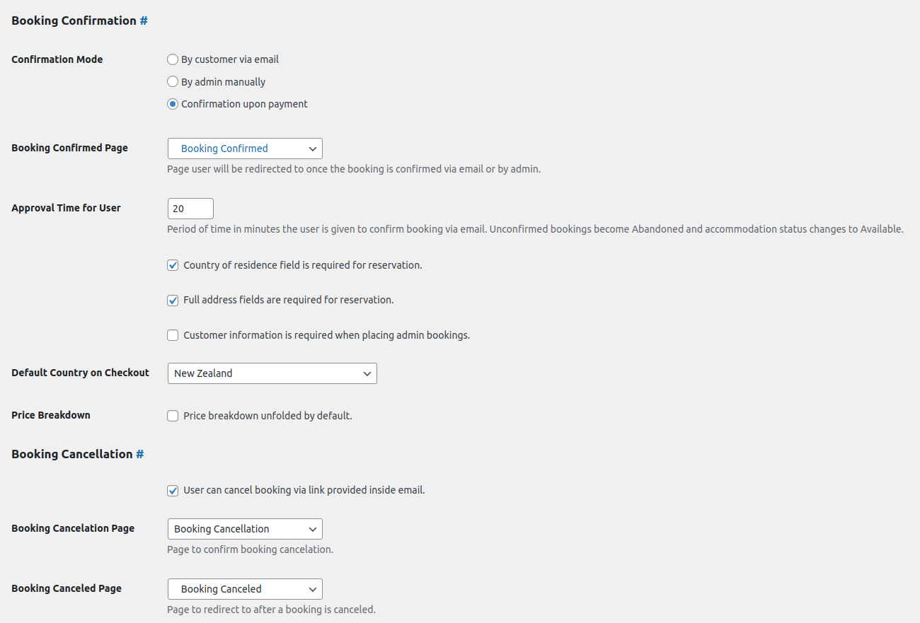

*Figure - Booking Settings*

### Payment Gateways

## Placing Bookings

After setting up the property and booking information, we can start placing bookings.

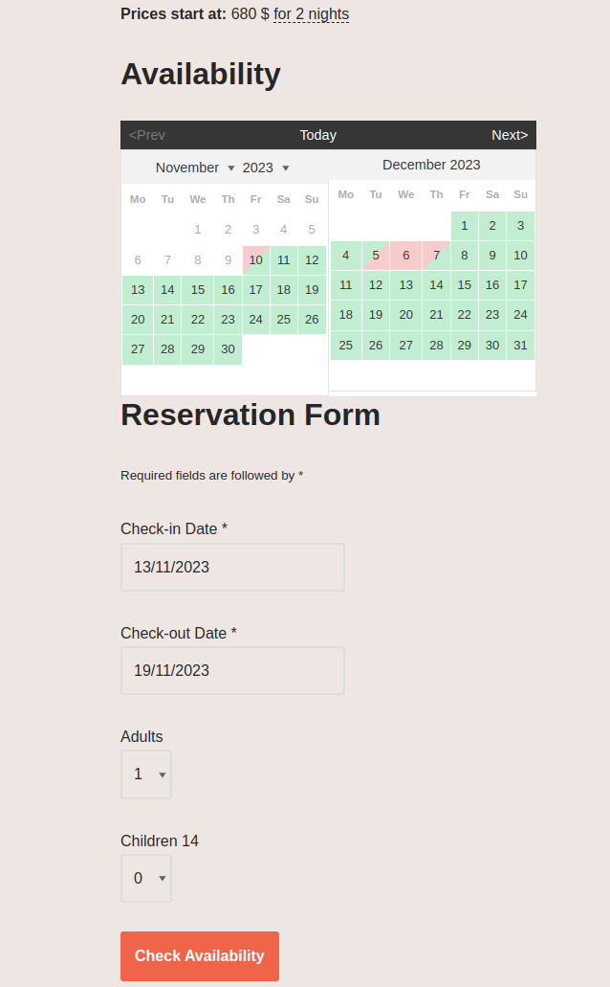

To place a booking we need an account. Please refer to …. to see how to create an account or log into an already existing account.

Navigate to a property to place a booking. At the bottom of the property entry, we find the availability calendar and a reservation form (Figure ). After selecting Check-in/out dates we can place a reservation (Figure ).

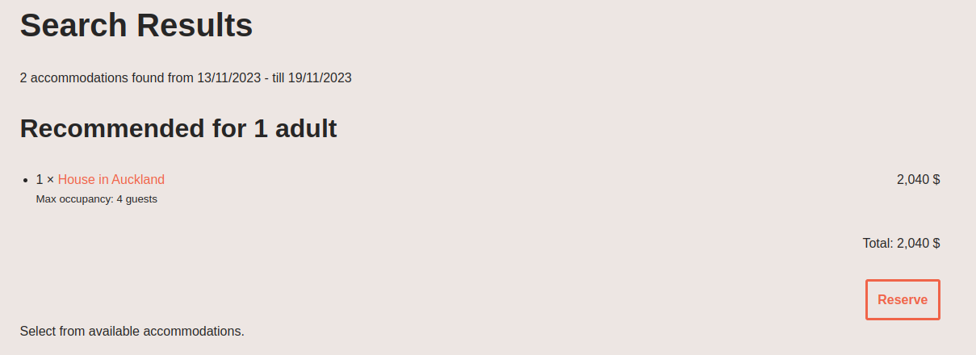

*Figure - Reserve Figure - Check Availability*

You will be asked to enter relevant personal information, select a payment method, and accept the terms & conditions (Figure ). By pressing “Book Now” the booking gets placed and the user gets redirected to the “Reservation Received” page as well as an e-mail notification with relevant booking information.

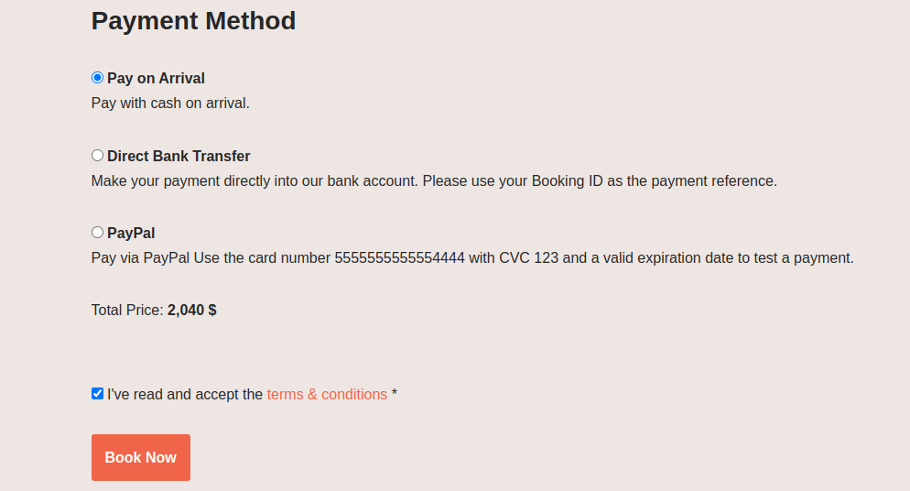

*Figure - Placing Booking*

Depending on the previously chosen settings as well as the payment method the status of payment and booking can be confirmed or on hold (Figure ).

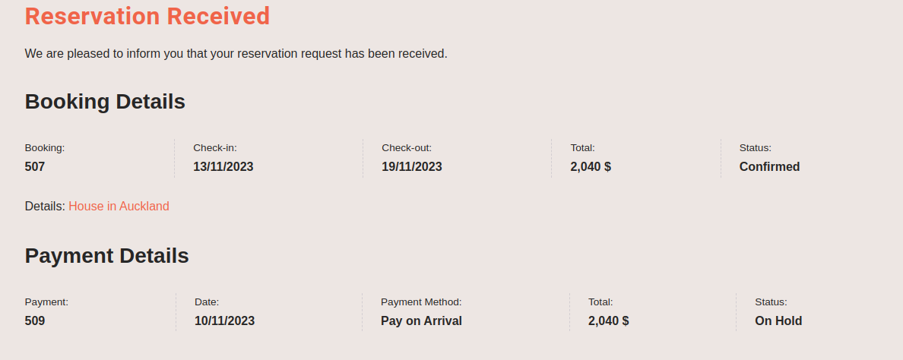

*Figure - Reservation Received*

## Manage Bookings

￼Navigate to Bookings/Calendar (Figure ). This overview presents all bookings and their status. Booking details can be viewed and payments added manually (Figure ).

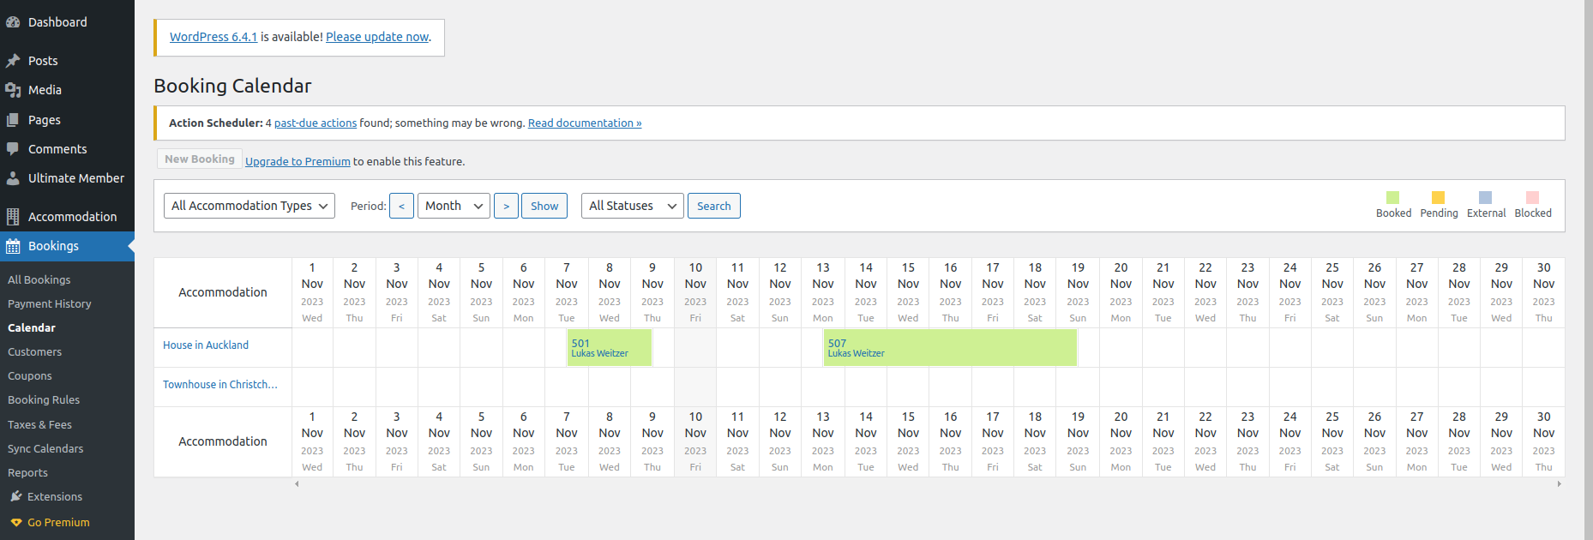

*Figure - Booking Calendar*

Bookings can be viewed, edited, and deleted when navigating to Bookings/All Bookings (Figure ).

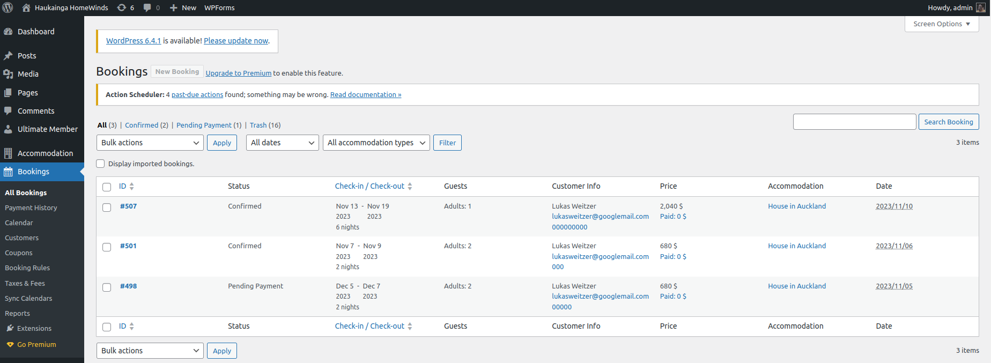

*Figure - All Bookings*

Payments can be viewed, edited, and deleted when navigating to Bookings/Payment History (Figure ).

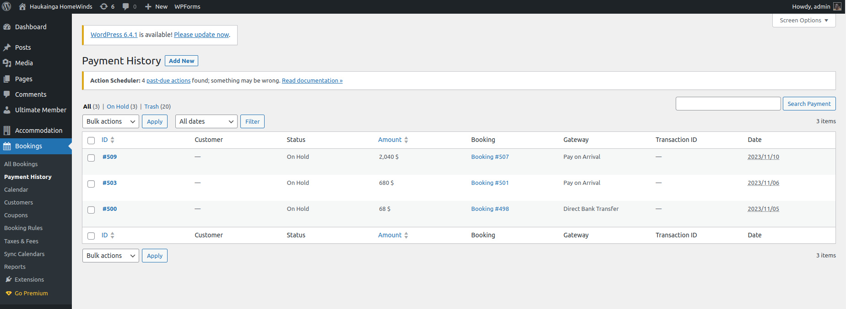

*Figure - Payment History*

Navigating to Bookings/Reports displays a report of business activities (Figure ). When upgrading the Hotel Booking Plugin these results could be exported as a CSV.

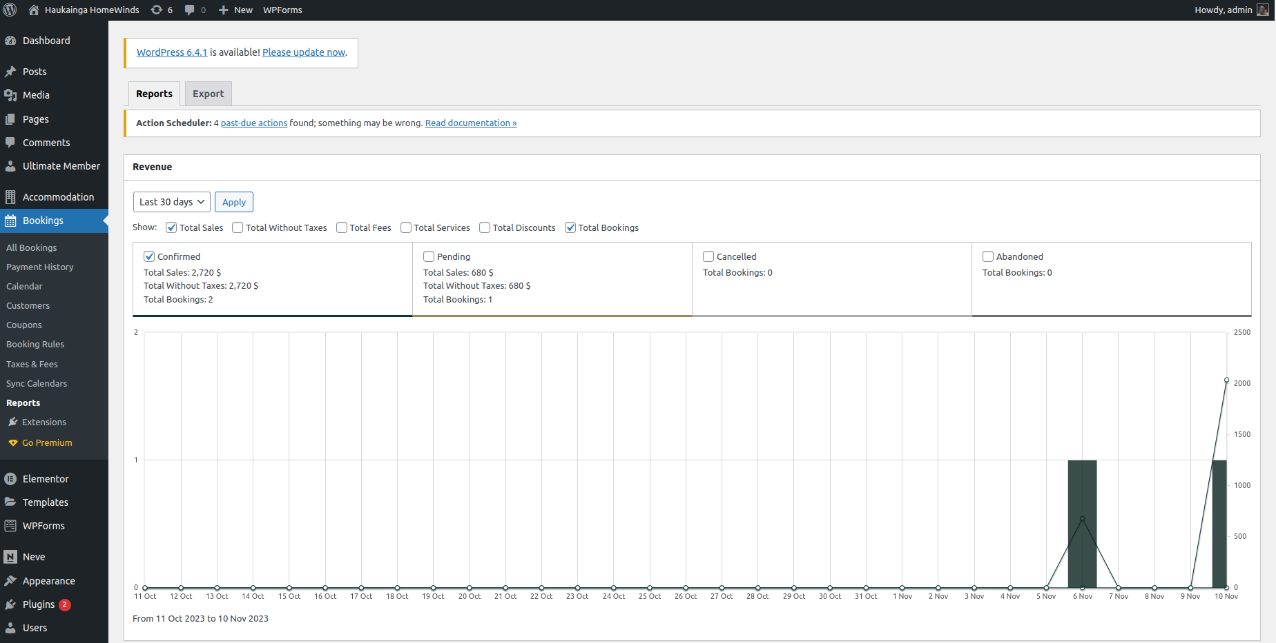

*Figure - Reports*

# User Management

# Additional Features

## WP Mail SMTP

Navigate to WP Mail SMTP. To test the e-mail services of the Hotel Booking Plugin we used the WP Mail SMTP Plugin. The Plugin comes with a Setup Wizard and supports various mail service providers. We used a mail account at Google. To set up this feature please refer to the Plugin documentation and follow the instructions provided by the Setup Wizard.

To alter the e-mail notification of the Hotel Booking Plugin navigate to Accommodation/Settings and alter the E-Mail settings.

## WP Forms

Navigate to WP Forms. We are using the WP Forms Plugin to provide users to contact the site administrator (Figure ). New Forms can be created and used as “Blocks” in the WordPress or Elementor Editor. Please refer to the Plugin documentation or hints when creating a new form.

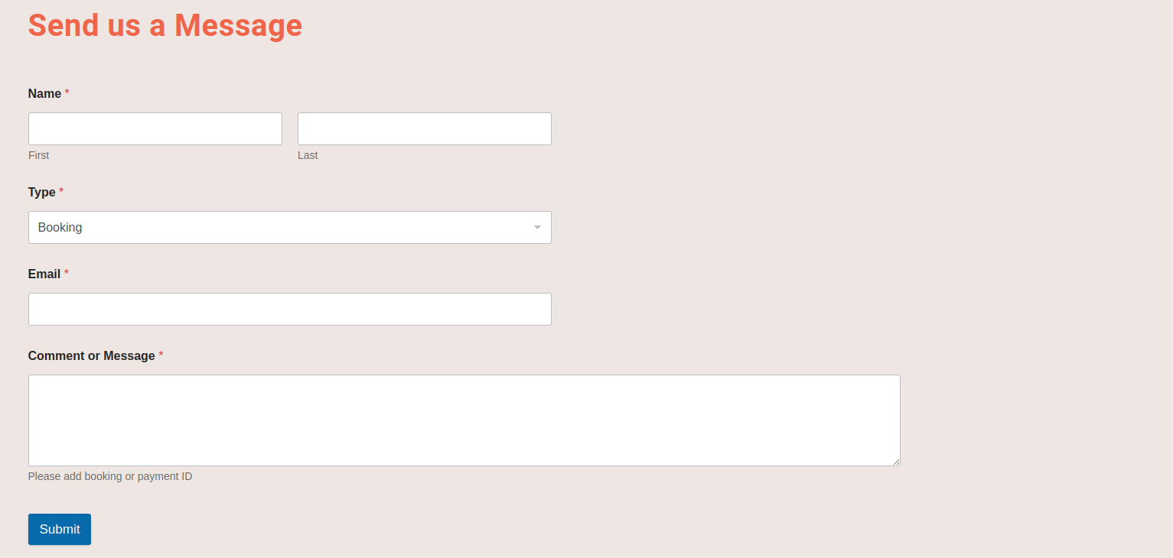

*Figure - Contact Form*

## 

# 

Sending Emails

For Testing porposes we used the plugin “WP Mail SMTP” to connect an external email service provider for sending all business related emails. They offer a wide variety of email providers to choose from. In our Testing scenario we used googlemail. The setup process is fast and easy. Tutorials are provided by the plugin to help during setup.

We would recommend choosing a hosting provider with email capabilities.